ECE 506 Research Credit Proposal

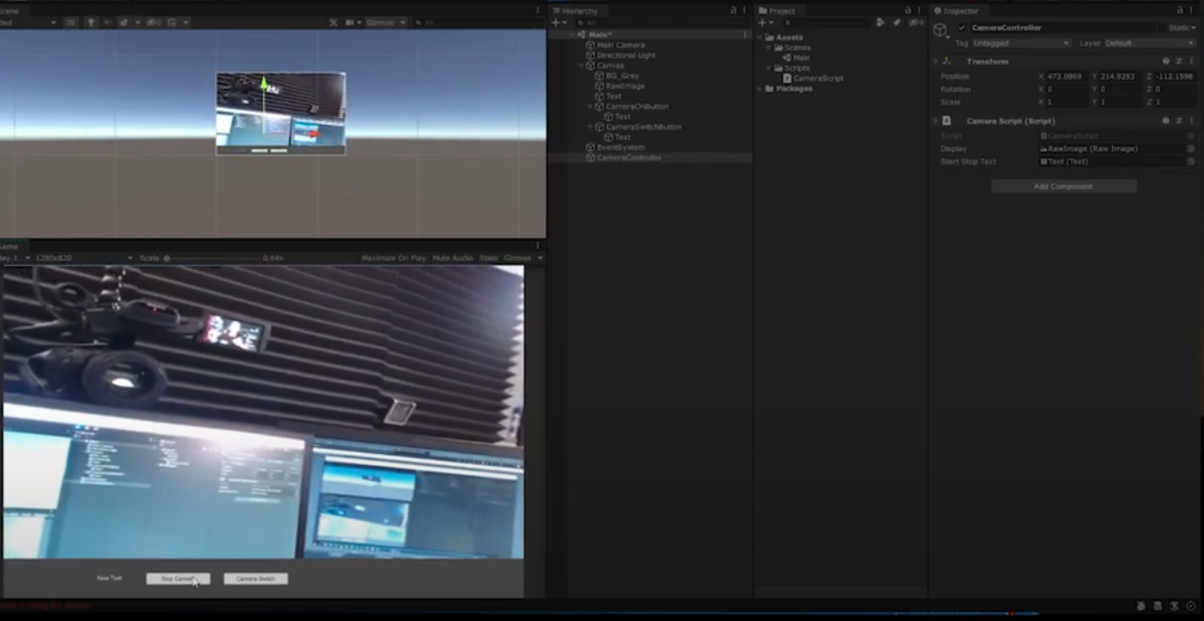

**Summary:** The proposal is to build an IOT Virtual Reality Environment with a camera live feed hooked up to a microcontroller, computer or GPU. The goal of this project is to learn how to interface a camera and eventually other components from a physical system to a virtual reality one. The inspiration for the project is to build a future work environment for blue collar workers to maintain a fleet of autonomous vehicles or drones. One could observe each vehicle similar to a security room full of CCTV’s and the cost would be significantly less. Various stats could be displayed around an instantiated camera such as safety, operation level, critical warnings and feedback from vehicle peripherals such as maintenance status, engine status ect…

Scope: The scope of this project is to build a VR environment with a camera display from a device.

Deliverables: Functioning VR environment with a camera display and one status item. Will include a brief one page report and other pages for instruction steps to build the environment as well as connection for the device.

Instructor Crouse Grading: Final deliverables shall be graded on A-F basis. Scale and background of grading TBD.

Final Demo

Report

*8/19